­­

**Great Books for Early Readers**

* **Biscuit by Alyssa Capucilli (series)**
* **On Track With Phonics (Thomas & Friends) by Wilbert Awdry**
* **Hello Kitty Phonics Boxed Set by Quinlan Lee**
* **Spongebob Phonics Box Set by Sonia Sander**
* **Spider Man Phonics Fun by Lucy Rosen**
* **Phonics Fun with Barbie by Jennifer Weinberg**
* **Tonka Phonics Box Set by Scholastic**
* **Fun with Zip and Zap by John Shefelbine**
* **Mice on Ice by Scholastic**
* **Star Wars Phonics Boxed Set by Quinlan Lee**
* **Why a Dog by A. Cat written by Michael Koontz**
* **Itchy, Itchy Chicken Pox by Grace Maccarone**
* **Mama Cat Has Three Kittens by Denise Fleming**
* **Tiny the Snow Dog by Cari Meister (series)**
* **Dr. Seuss books (series)**
* **Phonics: Boxed Set Lego City by Quinlan Lee**
* **Chimp and Chick’s Lunch Phonics Tales by Scholastic**
* **Clifford’s Phonics Fun Boxed Set #1 by Scholastic**
* **Scooby-Doo Phonics Box Set by Frances Ladd**
* **Dora the Explorer Phonics Boxed Set #3 by Quinlan Lee**
* **The Red Hen: Funny Tale Phonics by Judith Stamper**
* **Tug the Pup by Blue Apple Books**
* **12 Book Set by Usborne Phonics Readers**
* **Sam Sheep Can’t Sleep by Usborne Phonics Readers**
* **Friday the Scaredy Cat by Kara McManon**
* **Ant in Her Pants by Paul Orshoski**
* **Pinch and Dash and the Terrible Couch by Michael Daley**

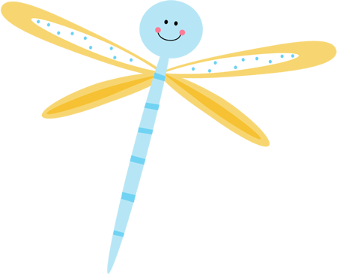



Clipart graciously provided by <www.mycutegraphics.com>

**Leveled Books**

**City Cats, Country Cats by Barbara Hazen Level C**

**Catch That Cat by Cari Muster Level C**

**Cat Traps by Molly Coxe Level D**

**Copy Cat by Olivia George Level E**

**Cat in the Bag by Sara Miller Level E**

**Cat’s Colors by Jane Cabrera Level E**

**Magic Matt and the Cat by Grace Macarone Level G**

**Otto the Cat by Gail Herman Level I**

**Cat in the Hat by Dr. Seuss Level J**

**Diva and the Flea by Mo Willems Level J**

**The Case of the Cat’s Meow by Crosby Bonsall Level K**

**Puss In Boots by Charles Perrault Level M**

**Skippy Jon Jones by Judy Schachiner Level N**

**How to Speak Cat: A Guide to Decoding Cat Language by Aline Newman Level N**

**Cat Language by Aline Newman Level N**

**Catwings by Ursula LeGuin Level N**

**Alone in the Night by Holly Webb Level P**

**Grumpy Cat by Grumpy Cat Level Q**

**Everything Cat by Marty Crisp Level R**

**Warrior (Series) by Erin Hunter Level S**

**Dewey the Library Cat by Vicki Myron Level S**

**Aristotle by Dick King-Smith Level U**

**There Are Cats in This Book by Viviane Schwarz**

**There Are No Cats in This Book by Viviane Schwarz**

**Pete the Cat (Series)**

Too Cool for School by Kimberly and James Dean Level E

A Pet for Pete by James Dean Level G

Pete the Cat and the Bad Banana by James Dean Level G

Pete’s Big Lunch by James Dean Level J

Pete at the Beach by James Dean Level J

Pete the Cat and His Four Groovy Buttons by Eric Litwin Level J

I Love My White Shoes by Eric Litwin Level K

Pete the Cat and His Magic Sunglasses by Eric Litwin and Kimberly Dean

Pete the Cat’s Groovy Guide to Life: Tips From a Cool Cat for Living an AwesomeLife by James and Kimberly Dean